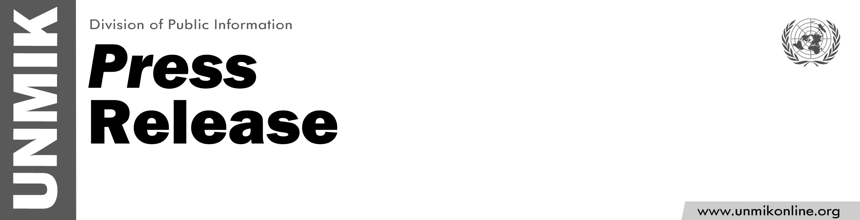

UNMIK/PR/1762
Thursday, 30 June 2011

SRSG Lamberto Zannier announces departure

PRISTINA - The Special Representative of the UN Secretary-General (SRSG) and Head of UNMIK Lamberto Zannier, announced today that he will be taking up the post of Secretary-General of the Organization for Security and Co-Operation in Europe (OSCE) and leave Kosovo.
Mr. Zannier, a senior Italian diplomat, took the helm of UNMIK on 21 June 2008 and served longer than any of his predecessors.
In announcing his departure, Mr. Zannier stated “It has been a privilege and an honour for me to serve as UNMIK SRSG. I have been proud to serve with the women and men of UNMIK, and they have my deepest gratitude for their dedication to the UN's mandate in Kosovo to promote security, stability and respect for human rights in Kosovo and in the region. I know they will keep up the good work. I am also very grateful for the support and cooperation of my international partners, the UN Kosovo Team, the OSCE, KFOR, EULEX and the other European Union organisations, and the diplomatic community. I look forward to continuing working on issues related to Kosovo from my new post at the OSCE. My thanks and heartfelt best wishes also go to the institutional and religious leaders from all communities with whom I have worked during these three years.

Mr. Zannier added "I am pleased to leave to my future successor an operation that is reconfigured and well-suited to the current challenges.
I trust UNMIK will continue to support all of Kosovo's communities in their road towards reconciliation, peace and prosperity and I encourage Pristina and Belgrade to fully engage in dialogue to resolve open issues."

