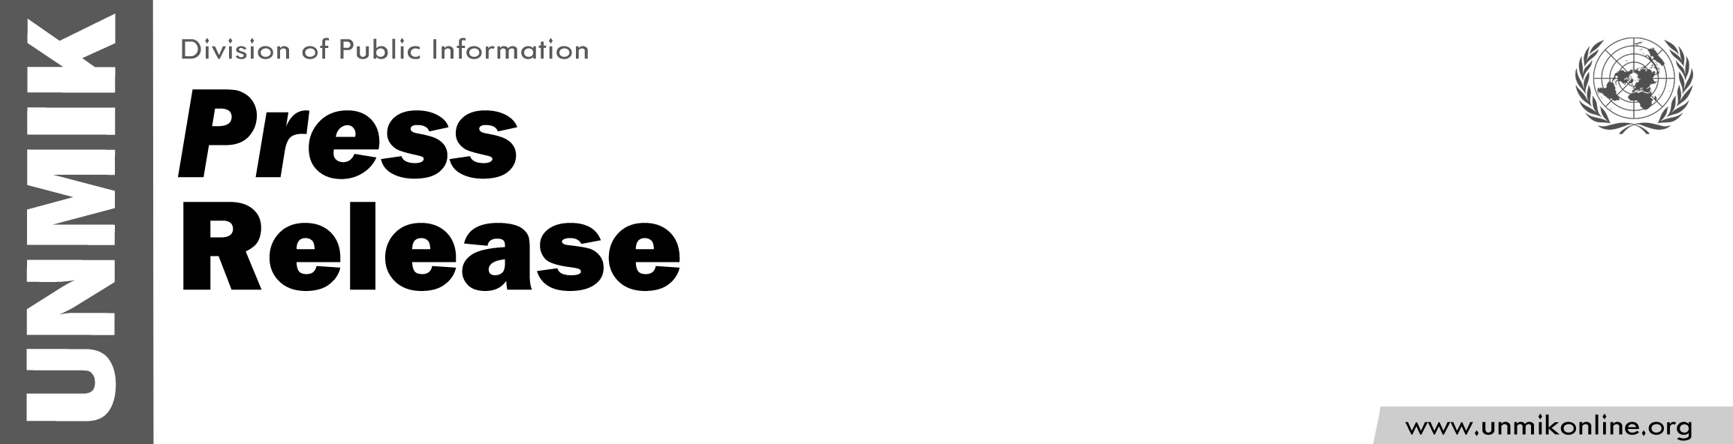

UNMIK/PR/1763
Friday, 1 July 2011

Mr. Robert E. Sorenson designated Officer-in-Charge of UNMIK

PRISTINA- As of 1 July 2011, Mr. Robert E. Sorenson has been designated Officer-in-Charge of UNMIK by UN Headquarters in New York. The decision was made following the departure of Mr. Lamberto Zannier.

Mr. Sorenson joined UNMIK in March 2009 as Chief of Staff. A former career U.S. diplomat with extensive experience of the Balkan region,
Mr. Sorenson also previously served in Kosovo as the Deputy Head of U.S. Office in Pristina from 2003 to 2004.

