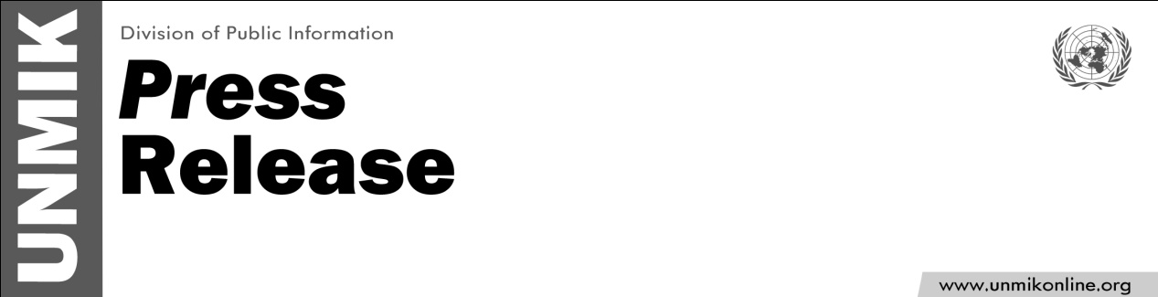

UNMIK/PR/1765
Wednesday, 3 August 2011

A/SRSG Farid Zarif Arrives in Kosovo

PRISTINA – Mr Farid Zarif arrived in Kosovo on Tuesday to take up the leadership of UNMIK in his new role as the Acting Special Representative of the Secretary-General.

Mr Zarif has an extensive field experience, having been UN Deputy Humanitarian Coordinator in Baghdad in the nineties, Chief of Staff of the UN Assistance Mission in Iraq (UNAMI) and later Acting DSRSG of the UN Mission in Sudan (UNMIS).

A national of Afghanistan, Mr Zarif has been a career diplomat and Deputy Foreign Minister. Mr Zarif studied Law, Diplomacy and International Relations at the Faculty of Law and Political Science of Kabul University, the Afghan Institute of Diplomacy and Oxford University.

Since August 2010 he is the Director of Europe and Latin America Division of the Department of Peacekeeping Operations at UN Headquarters.

