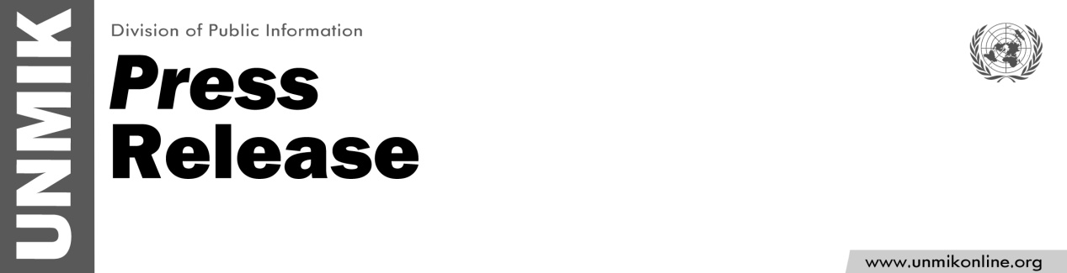

UNMIK/PR/1770
Friday, 23 December 2011

SRSG’s wishes for the festive season

PRISTINA – During this festive season I would like to wish all the people of Kosovo peace, hope and joy. This is a special time to reflect on our blessings together with our families and friends, to remember others who may suffer deprivation, discrimination or injustice and to strive through actions and words to achieve further advancement for all in the coming year.
2011 has been a year of challenges and achievements in Kosovo. It is my hope that we will jointly build on the positive steps undertaken this year and continue to make further progress in 2012.
In this spirit, I would once again like to extend to you my best wishes for a happy, healthy, prosperous and peaceful festive season.

