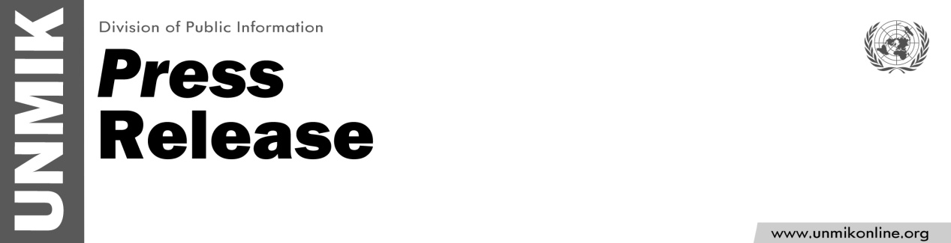

UNMIK/PR/1771
Monday, 09 April 2012

SRSG condemns Violent Attack at the Three Towers Complex in Mitrovica

PRISTINA – Special Representative of the UN Secretary-General in Kosovo (SRSG) Farid Zarif strongly condemned the bomb attack on Sunday morning at the Three Towers complex in northern Mitrovica. Mr. Selver Haradinaj, a 38 year-old husband and father of four children, was killed in the blast and two of his children were wounded.
“Our condolences go to the Haradinaj family who have our thoughts and prayers,” Mr. Zarif said and continued,
“This act of violence should be condemned by all. Everyone should cooperate fully with the investigation underway to ensure the perpetrator(s) are brought to justice swiftly. Further acts of violence cannot, and must not, be tolerated. Such acts can only threaten Kosovo’s peace and stability. I urge all residents to remain calm and let the responsible authorities undertake their duties,” Mr. Zarif said.

