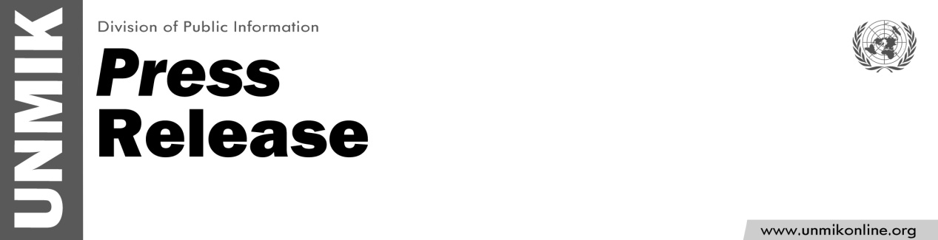

UNMIK/PR/1774
Tuesday, 19 June 2012

Statement Attributable to the Special Representative of the Secretary-General for Kosovo, Mr. Farid Zarif

PRISTINA – In response to the incident early this morning at the KFOR compound at Gate 31, near Brnjak, Zubin Potok, SRSG Farid Zarif stated that:
“Any use or threat of violence against international peacekeepers is unacceptable, and to be condemned in the strongest terms. I call upon everyone to fully cooperate with KFOR investigations to ensure the perpetrators are identified and brought to justice.”

