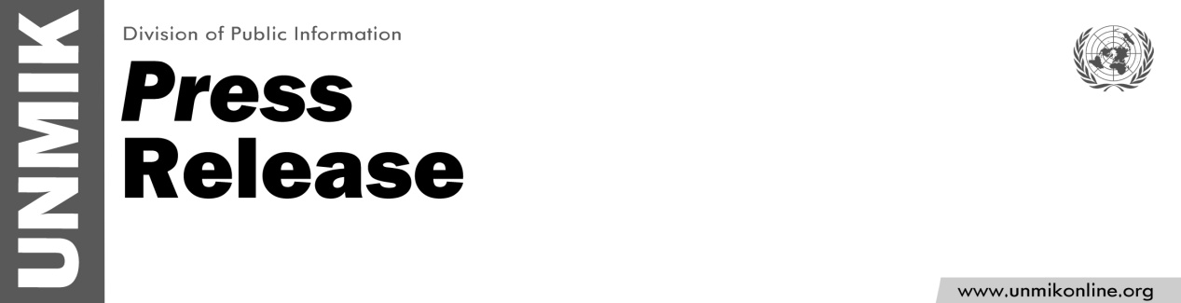

UNMIK/PR/1775
Thursday, 28 June 2012

SRSG condemns today's incidents and provocative acts

PRISTINA - SRSG Farid Zarif strongly condemns the incidents and provocative acts that occurred today in Kosovo, particularly the attack against a number of buses carrying passengers, mostly children of Serbian nationality.
The SRSG calls on competent authorities to conduct a complete and thorough investigation into these incidents and further calls upon all parties to refrain from any action which could exacerbate the situation.

