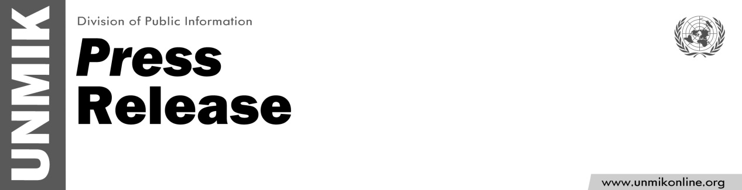

UNMIK/PR/1783
Wednesday, 10 October 2012
UNMIK remembers former PDSRSG Lawrence G. Rossin
The Special Representative of the Secretary-General Farid Zarif has expressed his condolences to the family of the former Principal Deputy of the Secretary-General Lawrence G. Rossin who served in UNMIK from October 2004 to February 2006 and from January 2008 to June 2008.
After he departed from UNMIK in 2006, Ambassador Rossin served as PDSRSG for the United Nations Stabilization Mission in Haïti (MINUSTAH). After leaving MINUSTAH and prior to returning to Kosovo for his second term as PDSRSG, Ambassador Rossin was the Senior International Coordinator for the Save Darfur Coalition. He also served as Deputy Assistant Secretary-General for Operations at NATO between 2008 and 2011.
Mr. Rossin died on Saturday, October 6th at the age of 59.
The SRSG today sent a letter of condolence to Mr. Rossin's family upon hearing of his passing.
“Larry's career is intimately linked with the history of UNMIK and Kosovo” said the letter.
“For his contribution in ensuring the success of the UN mandate, Larry is certainly one of the Mission leaders who left a positive mark in the mind and memory of colleagues and friends" it added.
On behalf of all the staff in UNMIK, and on his own behalf, the SRSG offered the Rossin family his heartfelt condolences.

