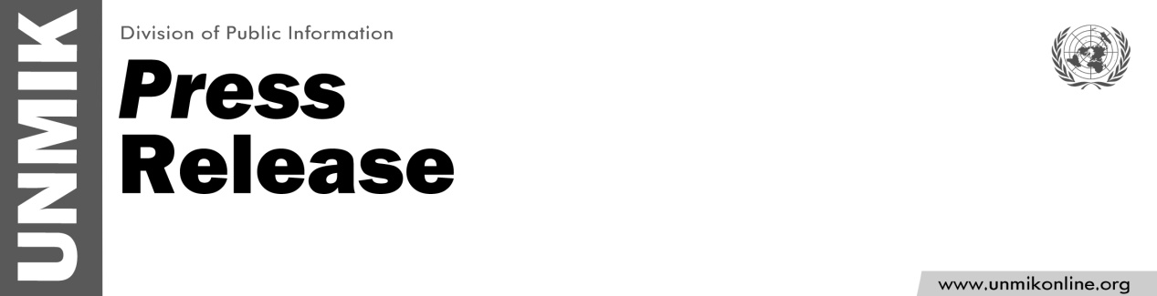

UNMIK/PR/1786

Thursday, 13 December 2012

UNMIK donates vehicles to the Kosovo police

PRISTINA - UNMIK donated six vehicles to the Kosovo police during a handover ceremony yesterday, which was attended by the Deputy SRSG Robert Sorenson and the Kosovo police director of the Department of Support Services, Kamer Jonuzaj.

"UNMIK is very pleased to be able to donate vehicles that will assist the Kosovo police in undertaking their duties in northern Kosovo, and around Kosovo, as well. These additional vehicles will help the Kosovo police to ameliorate the environment to nurture law and order," said Mr. Sorenson during the handover ceremony.

DSRSG Sorenson later met with the Kosovo police director of the Department of Support Services, Kamer Jonuzaj, to sign the handover papers and further discuss current events in Kosovo.

"We have been established by UNMIK and have grown together," said Mr. Jonuzaj, "The police service will always remember the support provided by UNMIK."

This visit was part of a series of continuing efforts by UNMIK to donate goods to communities, civil society, and Kosovo institutions.

In the coming weeks, UNMIK will visit 32 municipalities and donate over 300 items, such as vehicles and IT equipment.

