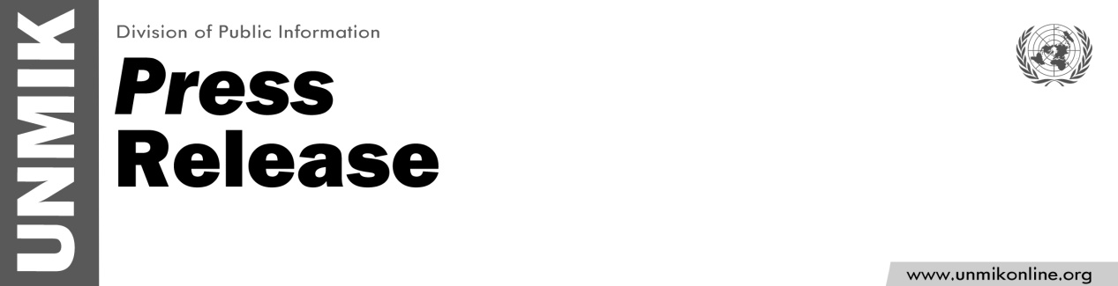

UNMIK/PR/1787
Monday, 17 December 2012

UNMIK SRSG condemns incident in Pristina

PRISTINA - Local magazine, Kosovo 2.0, organized a launch event for their latest issue on LGBT equality and discrimination on Friday evening.

In response, a group of protesters gathered in front of Pristina's Youth and Sports Center and used violence in preventing people from attending the presentation; the protesters entered the premises and proceeded to demolish the property on-site.

Once having confirmed all the facts, UNMIK SRSG Farid Zarif condemned the incident that led to the cancellation of the presentation.

“This is an attack on freedom of expression. Respect for the law and media freedom is fundamental in achieving durable peace and effective protection of human rights in Kosovo," said Mr. Zarif.

Focusing on LGBT-related issues, SRSG Zarif stressed the need for public education against any discriminatory practices in this regard.

He also called on rule of law authorities to investigate the incident and take appropriate measure to discourage the repetition of such intolerant behaviours.

