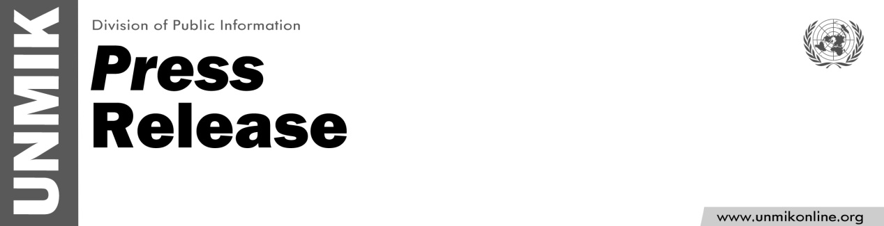

UNMIK/PR/1788
Monday, 24 December 2012

SRSG Farid Zarif's
wishes for the festive season

As we approach the Holiday Season, I would like to wish all the people of Kosovo peace, hope and joy.

This is a time for sharing our blessings and joy with our friends and family, to remember those who may suffer deprivation, discrimination or injustice and to strive through actions and words to achieve further advancement for all in the coming year.

May peace, happiness and hope prevail in our hearts during this very special period, as well as throughout 2013.

In this spirit, I would like to convey my very best wishes for a peaceful and joyous festive season to all of you.

Season’s Greetings and Happy Holidays!

