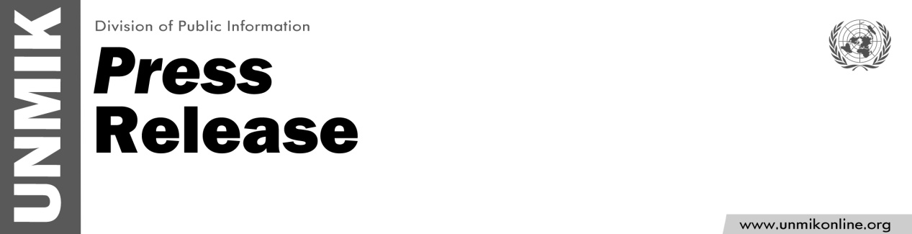

UNMIK/PR/1789
Monday, 7 January 2013

SRSG Farid Zarif's message
on the occasion of Orthodox Christmas

PRISTINA – Special Representative of the Secretary-General in Kosovo Farid Zarif issued the following message on the occasion of Orthodox Christmas:

“The holiday season is a time to be with loved ones and share in the spirit of peace and harmony. On behalf of everyone in UNMIK, I wish prosperity and good tidings to all celebrating Orthodox Christmas.

May this joyous occasion promote good will and mutual respect among people of all faiths in Kosovo.

Merry Christmas! Srećan Božić!”

