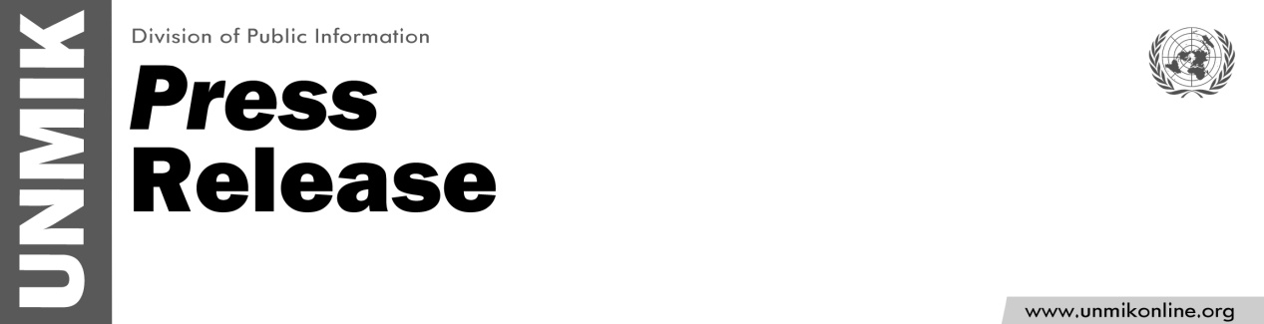

UNMIK/PR/1792
Tuesday, 28 March 2013

UNMIK condemns threats and violence
against human rights activist

PRISTINA – UNMIK strongly condemns the recent threats directed towards a human rights activist in Pristina.

Women's rights advocate, Ms. Nazlie Bala, was recently sent a threatening letter relating to her efforts to help promote the rights of women, particularly those who have been victims of sexual abuse related to the conflict in Kosovo.

UNMIK also deems the assault on Ms. Bala as a fundamental infringement of her human rights and a flagrant attack on freedom of expression.

Sustained efforts must be undertaken to guarantee the safe and secure environment for all who may be threatened due to human rights activities, or the expressions of their opinions.

UNMIK calls on Kosovo authorities to conduct a complete and thorough investigation into this and other incidents, including all acts of violence against human rights activists.

