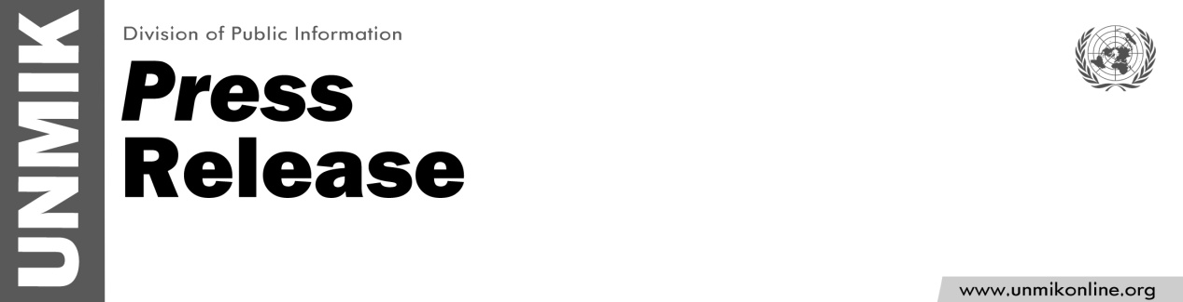

UNMIK/PR/1793
Tuesday, 29 March 2013

UNMIK message on the occasion of Easter

PRISTINA – On the occasion of Easter, UNMIK sends its sincere wishes to all communities in Kosovo who observe Easter.

Easter is a time to celebrate love, sacrifice, and hope for a better world; it is an occasion that reminds us also of humanity’s ability to embrace adversity, as well as capacity for forgiveness. Easter also marks an opportunity for communities in Kosovo to celebrate with their neighbours in harmony.

UNMIK wishes you all health, peace, and happiness, and may the joy of Easter find a place in your hearts.

