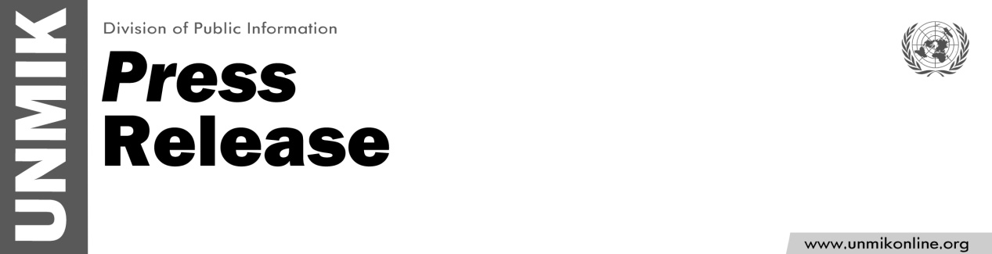

UNMIK/PR/1795
Friday, 3 May 2013

UNMIK Message On World Press Freedom Day

PRISTINA, 3 May 2013 – As we mark World Press Freedom Day, UNMIK strongly condemns recent attacks and threats against journalists and most recently yesterday’s violent incident targeting the RTK’s editor in chief, Mr Limani, and his family.

Such instances undermines freedom of expression and free media in Kosovo.

Defenders of a free press are safeguarding people's rights and one must, in turn, ensure theirs.

The theme of this year’s World Press Freedom Day, “Safe to Speak: Securing Freedom of Expression in All Media”, highlights the need for action to upholding the right of journalists to carry out their vital work professionally.

On the occasion of the World Press Freedom Day, UNMIK calls on all concerned to do their utmost to enable journalists in all media to perform their work, which is an indispensable feature of healthy and peaceful societies.

.

