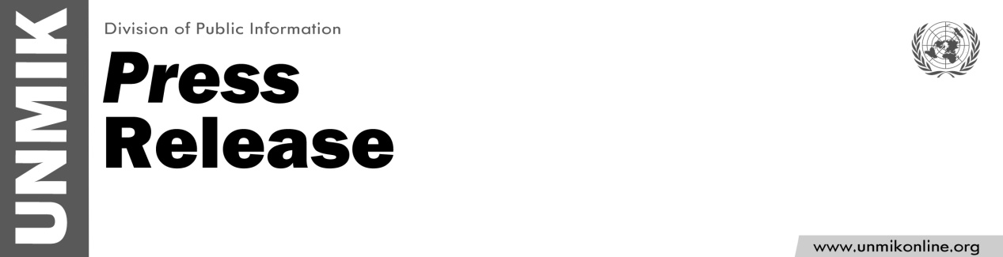

UNMIK/PR/1801
Monday, 14 October 2013

UNMIK SRSG condemns bombing in North Mitrovica

PRISTINA – UNMIK SRSG Farid Zarif strongly condemns the bombing incident that occurred this morning in northern Mitrovica, which targeted the home of a Kosovo Serb, Nebojsa Maric, and caused extensive property damage to his house, neighbouring buildings, as well as a vehicle.

"These cowardly acts of violence are reprehensible, and they gravely jeopardise security and stability in the region," stated SRSG Zarif.

UNMIK SRSG calls for a swift and thorough investigation into this incident. “I also stress that rule of law authorities must take effective measures to prevent such violent acts,” added Mr. Zarif.

"I have personally received strong assurances from all sides of the debate in northern Kosovo that acts of force and intimidation will not to be tolerated, and thus I look to local leaders to ensure the highest degree of assistance to law enforcement. Any misguided attempt to undermine stability during the elections process should be dealt with as a matter of the highest priority," said SRSG Zarif.

The SRSG urged anyone with information about this incident to cooperate with investigators so that the perpetrators can be brought to justice. "These acts of violence must cease," concluded Mr. Zarif.

