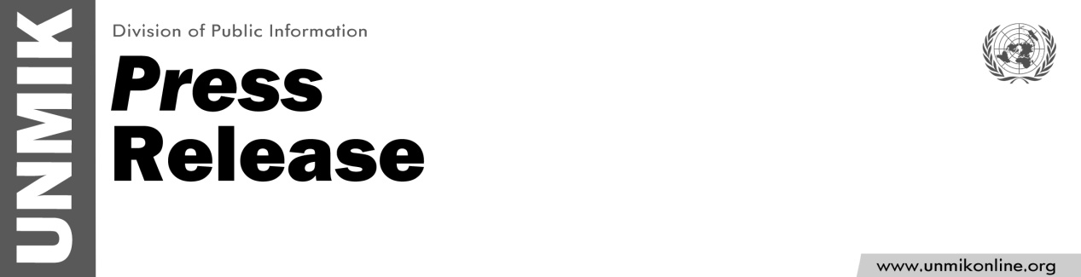

UNMIK/PR/1813
17 December 2014

UNMIK chief meets with new Kosovo prime minister

PRISTINA – The Special Representative of the Secretary-General (SRSG) and Head of the United Nations Mission in Kosovo (UNMIK), Farid Zarif, met today with the new Prime Minister of Kosovo, Mr. Isa Mustafa.

The SRSG congratulated the Prime Minister on the formation of the new government, and the two discussed the future, including the Prime Minister's immediate priorities, which include in particular stimulation of the economy and the creation of jobs. They also spoke about the Prime Minister’s commitment to improving education, promoting tolerance and respect among Kosovo’s communities, and proceeding with vital political processes including the EU-facilitated dialogue with Belgrade.
The SRSG and the Prime Minister agreed to remain in regular contact.

For more information: Brenden Varma, varmab@un.org, 044500107; Shpend Berbatovci, berbatovci@un.org, 044503074

