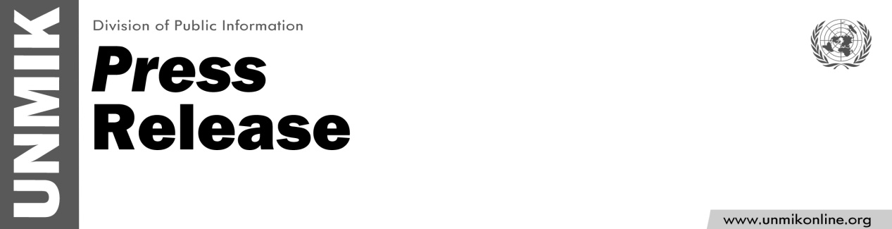

UNMIK/PR/1816
Thursday, 06 August 2015

UNMIK moves to new premises
PRISTINA – The relocation of the headquarters of the UN Mission in Kosovo (UNMIK) to new premises was completed today.
The Mission is now located in the buildings formerly occupied by Bucaj in Fushë Kosovë/Kosovo Polje. UNMIK's mailing address and telephone numbers remain unchanged.

For more information, contact: Sarah Crozier, croziers@un.org 044 500 107 or Shpend Berbatovci, berbatovci@un.org, 049 136 661

