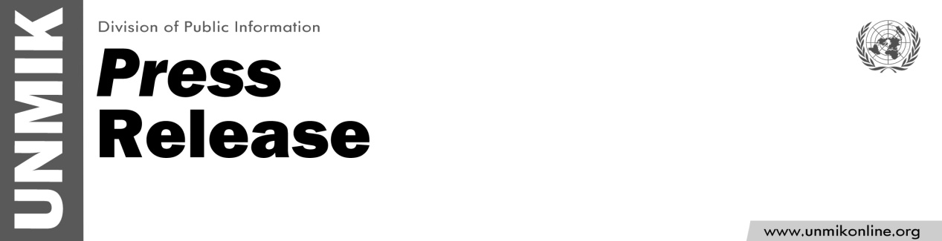

UNMIK/PR/1817
Friday, 9 October 2015

UNMIK condemns unacceptable violence in Kosovo Assembly
PRISTINA – UNMIK strongly condemns the violence that took place yesterday in the Kosovo Assembly, in which representatives of certain opposition parties obstructed the session by extreme means, leading even to some of those present to require medical attention.
Such actions have no place in a democratic society. They work directly against the interests of Kosovo and the interests of all those who have democratically elected their representatives to the Assembly. UNMIK urges that such scenes must not be repeated, and calls upon the opposition parties to fulfill their duties responsibly, by mature and constructive participation in the work of the Assembly.
For more information, contact: Sarah Crozier, croziers@un.org 044 500 107 or Shpend Berbatovci, berbatovci@un.org, 044 503 074

