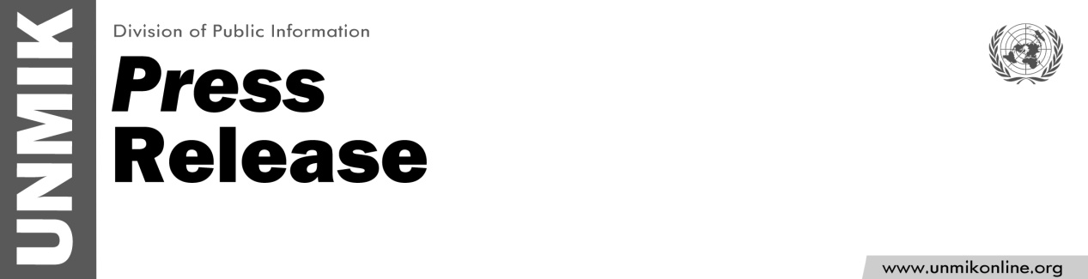

UNMIK/PR/1818
Friday, 9 October 2015

SRSG Zahir Tanin arrives in Kosovo
PRISTINA – Mr. Zahir Tanin arrived in Kosovo on Tuesday to take up the leadership of UNMIK as Special Representative of the Secretary-General.
Mr. Tanin previously served as Permanent Representative of Afghanistan to the United Nations from 2006, during which time he led international negotiations, chaired UN committees and served as Vice-President of the General Assembly. Prior to this, he was an analyst, producer, and editor at the BBC World Service, and a research fellow in International Relations at the London School of Economic and Political Science. Mr. Tanin graduated from Kabul Medical University in 1980.
For a full biography, please see: http://www.unmikonline.org/Pages/Leader.aspx
For more information, contact: Sarah Crozier, croziers@un.org 044 500 107 or Shpend Berbatovci, berbatovci@un.org, 044503 074

