Community Trust Building Projects

2026 – 2027



Call for Community Trust Building Projects

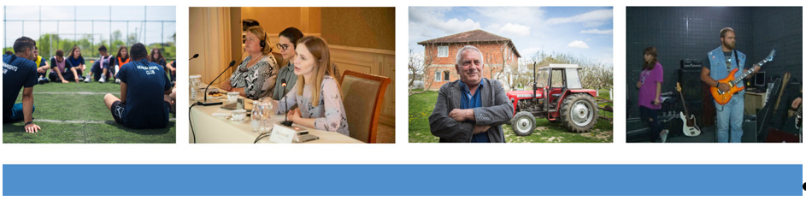
UNITED NATIONS INTERIM ADMINISTRATION MISSION IN KOSOVO (UNMIK)
Call for Community Trust Building Project Proposals 2026 – 2027
Deadline for submission: Tuesday 14 April 2026

A. Background and Purpose of this Call
Proposals are invited for small-scale, low cost, rapidly implementable projects, of benefit to the people of Kosovo, developed and implemented in a participatory manner, which seek to promote trust-building, reconciliation and inter-ethnic cooperation in ethnically mixed areas and among the different communities living in Kosovo, and which facilitate integration and cooperation among communities.
This call is launched now for projects to be implemented during the financial year July 2026 – June 2027. Project funding is subject to ulterior confirmation of project funds being made available in UNMIK’s 2026 – 2027 budget.
Please note that the result of the selection of the projects that will be funded may only be available in autumn 2026. All applicants will be notified by e-mail on the selection or non-selection of their project.
B. Aim, Objectives and Themes
Projects should promote (a) inter-municipal and inter-ethnic cooperation; (b) the provision of basic services at the community level to stimulate cooperation and reconciliation between communities; or (c) the resolution of economic, social, cultural or environmental issues at the local level. The common thread that all projects must have, is an element of inter-community cooperation.
C. Maximum Budget and Project Duration
Submitted projects shall not exceed USD 25,000 in value. Project budgets do not need to be close to this upper limit, smaller budgets are very welcome. Projects shall be implementable within 6 months.
D. Submission Deadline
The deadline for submission of proposals is 23:59 Hours CEST (Central European Summer Time) on Tuesday 14 April 2026. Every applicant will receive a return e-mail message notifying receipt of their project proposal by UNMIK.
E. Eligibility Criteria
Submitting entities must:
1. Be reputable not-for-profit organizations including local NGOs (including local branches of international NGOs), local authorities and government institutions. For-profit organizations and private companies cannot submit Community Trust Building Project proposals;
2. Be legally recognized and registered with the relevant Kosovo authorities and have qualified personnel including a physical address, email and telephone contact that can be verified;
3. Demonstrate transparency, accountability and efficiency in the use of resources;
4. Demonstrate understanding of and compliance with UN standards of conduct with respect to the prohibition of sexual exploitation and abuse;
5. Have an account with a reputable banking institution.
6. Proven competencies demonstrated by previous, successful project / programme implementations will be an asset.
F. Acceptability Requirements
Applications shall comply with the following requirements:
1. Proposals must be received no later than the deadline for submitting applications referred to in section D above.
2. They must be submitted in English using only the 2026-2027 application form provided herewith on the website. All sub-sections of the form must be filled, and all questions must be answered. Other formats or documents are not accepted.
3. The application form must be accompanied by a detailed budget, using only the provided 2026-2027 budget form template. Other formats or documents are not accepted. Project proposal budgets must not exceed USD 25,000.
4. Projects shall be implementable within 6 months.
5. Proposals need to demonstrate how implementation will promote (a) inter-municipal and inter-ethnic cooperation; (b) the provision of basic services at the community level to stimulate cooperation and reconciliation between communities; or (c) the resolution of economic, social, cultural and environmental issues at the local level; and how it will facilitate inter-community cooperation in Kosovo.
6. Projects may take a variety of forms, including limited infrastructure-related projects, the provision of equipment, short-term employment-generating activities to empower communities, non-recurrent training activities, awareness creation on human rights, gender, and youth issues to enhance inter-ethnic trust-building and cooperation; the holding of trust-building or similar fora, and so on.
7. Proposals should be sensitive to the evolving public health situation, presenting an option of project implementation in line with public health preventive measures, should these be reintroduced (e.g. online or outdoor meetings or other options to avoid gatherings of large groups of people, etc.) and a back-up implementation plan in case these measures become more restrictive again.
8. Proposals that can point to co-funding or otherwise show their sustainability beyond the initial UNMIK funding, will be considered favourably.
9. All applications should meet the eligibility criteria provided in section E above and the provisions of sections B and C. Failure to comply with the requirements will lead to the disqualification of the application.
10. All proposals that meet the above requirements and eligibility criteria will be given equal attention and will be evaluated by a Project Review Committee (PRC), which will make recommendations to the Head of Mission as to which projects best meet the priorities of the Mission. There is no guarantee that submitted project proposals will be selected, even if they meet the minimum criteria. Applicants will be duly notified of the outcome of this process.
11. Project funding is subject to ulterior confirmation of project funds being made available in UNMIK’s 2026-2027 budget.

If your project proposal meets the above criteria and has a reasonable budget, please submit by e-mail unmik-cbmp@un.org to the United Nations Mission in Kosovo (UNMIK)

G. Forms
The new 2026-2027 application form must be completed in English and must be accompanied by the new 2026-2027 budget form. All sub-sections of the application form must be filled. No other formats will be accepted.
1. Application form
UNMIK Community Trust Building Project: Proposal Application Form – 2026-2027.doc
2. Budget form
UNMIK Community Trust Building Project: Proposal Budget Form – 2026-2027.doc
+++++++++++++++++++++++++++

