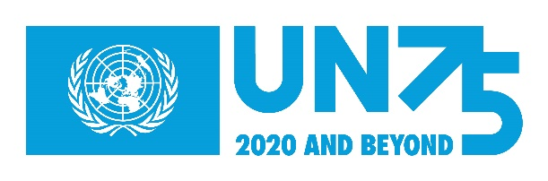
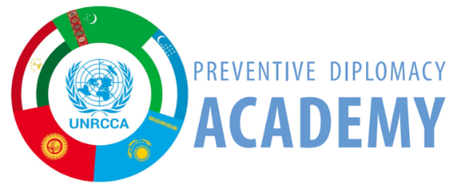
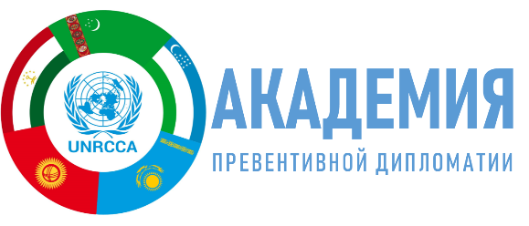
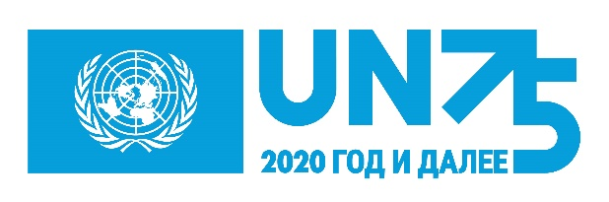

Youth Voices from Central Asia
UN75 and Regional Peace and Security

Essay contest: What do we want to say?

So you have decided to participate in this contest.

And since the aim of the contest is to hear the voices and ideas of the youth of Central Asia and Afghanistan, you have to dive into a theme, like the two most important UN agendas, “Youth, Peace and Security” and “Women, Peace and Security,” or topics like regional peace and security , preventive diplomacy and the UN Security Council.

Here you can familiarize yourself with a very brief history of these issues and you can get information about internet resources that will help you navigate the huge flow of information and use your time wisely. Let’s start with the UN Security Council.

- 1. UN Security Council

The Security Council is one of the six principal organs of the United Nations and plays a leading role in maintaining peace and security. It consists of 15 members (5 permanent and 10 non-permanent, elected by the UN General Assembly for a 2-year term). In accordance with Chapter VII of the Charter, the Security Council may take coercive measures to maintain or restore international peace and security. Such measures range from economic sanctions to international military action. The Council also establishes UN peacekeeping operations and special political missions.

Using this link you can familiarize yourself in detail with the work of the UN and all its six main bodies: https://www.un.org/en/about-un/index.html. The Security Council issues resolutions that are binding on all UN members.

- Youth, Peace and Security

In countries where there is conflict and violence, young people are, as a rule, seen as perpetrators or victims. Often, unrest and instability occur in countries with a large percentage of young people. The intensification of terrorism and violent extremism over the past 15 years has been associated with the role of youth and, increasingly, young women. But in reality, the role of young people in peace and security has not been sufficiently explored in all its complexity and ambiguity, and such stereotypes only hinder solutions to the problems of youth and women. Recognizing the need to solve this problem, the UN Security Council has adopted two resolutions on “Youth, Peace and Security” (YPS): 2250 (in 2015) and 2419 (in 2018), thereby laying the foundation of this agenda.

The first, resolution 2250 of 2015, recognized the potential of youth in preventing and resolving conflicts for the first time. This resolution calls for the elimination of factors leading to the rise of radicalization into violence and violent extremism among young people. The resolution also instructed the UN Secretary-General to conduct an independent study on the positive contribution of youth to peacebuilding and conflict resolution, which was completed in March 2018 under the title “The Missing Peace.” This served as the basis for the subsequent resolution 2419.

The second, resolution 2419 of 2018, recognized the positive role of youth in the negotiations, implementing peace agreements and conflict prevention. It calls on all countries and parties to seriously consider the views of young people and to promote their equal and full participation in decision-making processes at all levels. This resolution requested a report on the implementation of both Resolutions 2250 and 2419 from the Secretary-General by May 2020. That report was published in March 2020.

It is also important to familiarize yourself with the UN Youth Strategy, which will help you understand the general context of working with youth and the challenges we face in advancing the principles of equal rights and opportunities, both among generations and in the gender dimension.

- Women, Peace and Security

The results of the violence and wars in Rwanda, Bosnia, Northern Ireland, the Middle East and South Africa in the 1990s showed that conflict has a disproportionately worse impact on women and girls. In October 2000, at the request of women peacekeepers, the Security Council broke its silence on the issue and provided a platform for women's voices on issues of peace and security.

Since then, the Security Council has adopted ten resolutions on Women, Peace and Security (WPS): 1325 (2000), 1820 (2008), 1888 (2009), 1889 (2009) 1960 (2010), 2106 (2013), 2122 (2013), 2242 (2015), 2467 (2019), 2493 (2019). All 10 WPS resolutions together represent the Women, Peace and Security Agenda. This agenda has a transformational potential: to break the vicious circle of conflict, create an inclusive and more democratic peacekeeping and cast a spotlight on gender-related justice (leaving gender inequality in the past).

The first resolution 1325 (2000) highlighted the role of women in conflict prevention and resolution for sustainable peace and security. Today, this Agenda is recognized throughout the world but serious obstacles remain in implementing it. Patriarchy, inequality, militaristic masculinity (a culture and norms of aggressiveness and assertiveness) and discriminatory power structures impede effective conflict prevention, inclusive peace and the rights and participation of women. Detailed information on the Women, Peace, and Security Agenda will give you ideas for your essay.

These publications will broaden your horizons and understanding of the complex nature of the problems of WPS:

https://peacemaker.un.org/sites/peacemaker.un.org/files/GuidanceAdressingConflictRelatedSexualViolence_UNDPA%28english%29_0.pdf

https://peacemaker.un.org/sites/peacemaker.un.org/files/1.%20English%20-GIMS_0.pdf

- Regional peace and security in Central Asia and Afghanistan

Recognizing the key role of the countries of Central Asia and Afghanistan in ensuring peace, stability and sustainable development in the region, the General Assembly in 2018 adopted a resolution on strengthening regional and international cooperation in Central Asia. You can find general information on the context and the general political situation in the region from a number of sources:

https://www.ucentralasia.org/Content/Downloads/UCA-IPPA-WP-10-RegionalOrganizations.pdf

https://www.international-alert.org/sites/default/files/CentralAsia_PeacebuildingStrategicFramework_EN_2006.pdf

- Preventive diplomacy

The most effective way to reduce human suffering and the enormous economic costs of conflicts and their consequences is to prevent conflicts before they start. For this, the UN uses preventive diplomacy. Peacekeeping tools such as special envoys and special political missions are also at the Organization’s disposal.

In 2016, the Security Council adopted resolution 2282 on sustaining peace. The text provides can help you understanding the general architecture of peacebuilding and the relationships among the YPS and WPS agendas and preventive diplomacy.

Additional information on preventive diplomacy: http://www.cawater-info.net/pdf/jenca.pdf

This 2012 report of the UN Secretary-General provides a good overview of the opportunities and challenges for preventive diplomacy in a changing political and security landscape. Focusing specifically on diplomatic action taken to prevent or mitigate the spread of armed conflict, the report describes the relevance of preventive diplomacy across the conflict spectrum and as part of broader, nationally owned strategies to promote peace.

And, finally,

A lot of information has been published on the events of the past few months in English and unfortunately less has been published in Russian. Use these links to find the latest publications on COVID-19:

- https://www.youthcompact.org/the-compact-response (Eng)
- https://static1.squarespace.com/static/5b2d24e39d5abbe187e75234/t/5ebf1d6c3106261d47fd1120/1589583217534/COMPACT+COVID19-Summary.pdf (Eng publication: Guidance Summary: COVID-19: Working with and for young people)
- https://www.youth4peace.info/system/files/2020-05/COMPACT%2BCOVID%2B18_05.pdf (Eng publication: COVID-19: Working with and for young people).
- https://en.unesco.org/sites/default/files/iaynd_statement_on_covid-19_and_youth_final.pdf (Eng) Statement on COVID-19 and youth of United Nations Interagency Network on Youth Developmeny

